**Triangle Congruence**

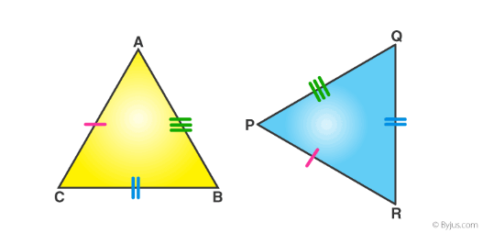Side-Side-Side (SSS)

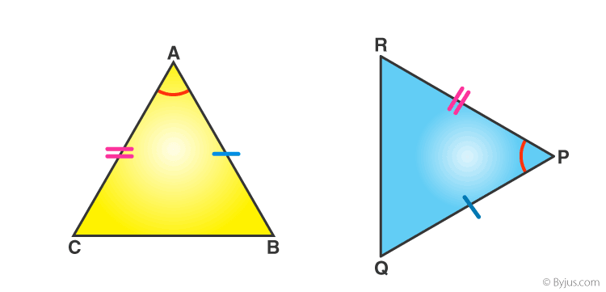

Side-Angle-Side (SAS)

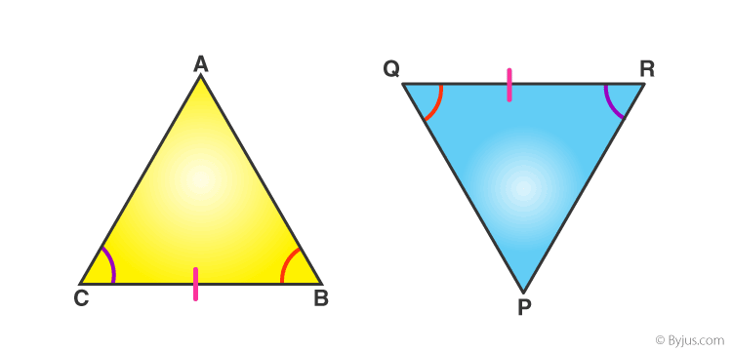

Angle-Side-Angle (ASA)

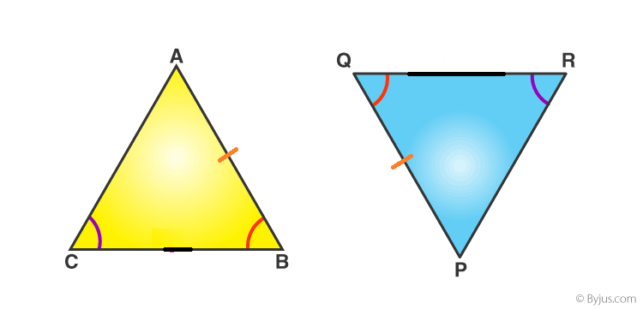

Angle-Angle-Side (AAS)

**Right Triangle Congruence**

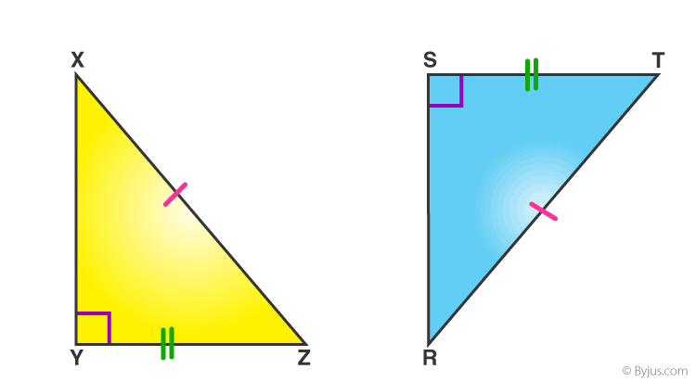

Hypotenuse-Leg (HL)

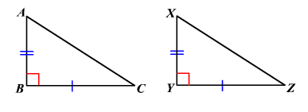Leg-Leg (LL)

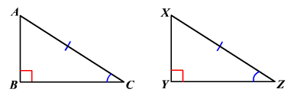Hypotenuse-Angle (HA)

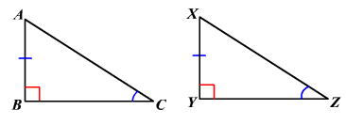Leg-Angle (LA)